**Root Mean Squared Fluctuation**

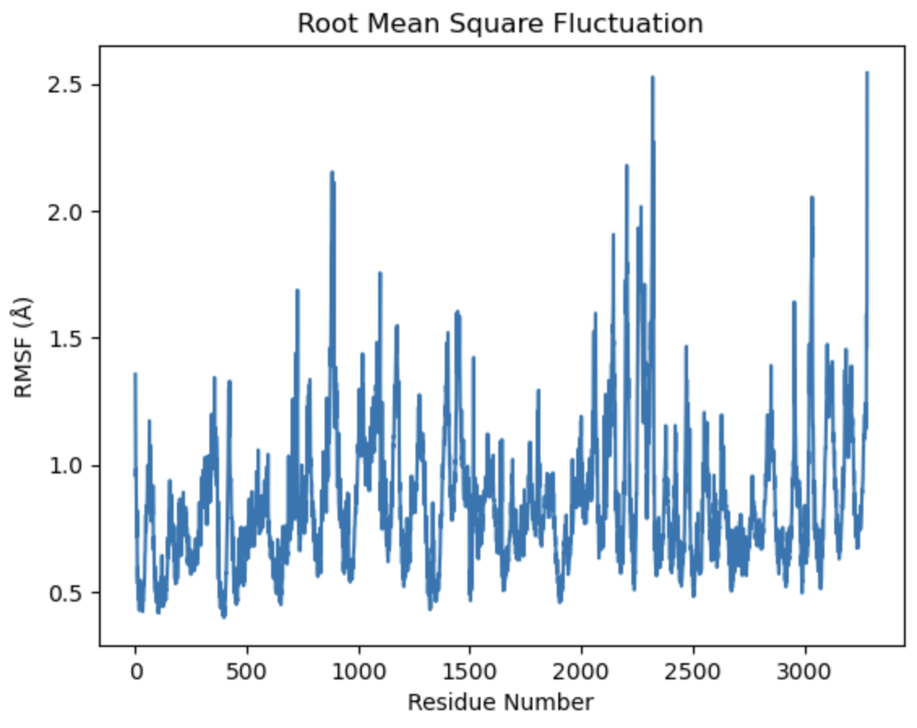

import MDAnalysis as mda

from MDAnalysis.analysis import align, rms

# Load the universe

u = mda.Universe('/Users/josephsteward/Downloads/npt.gro', '/Users/josephsteward/Downloads/md_100ns.xtc')

# Select the atoms of interest (e.g., backbone of a protein)

protein = u.select_atoms('protein and backbone')

# Align the trajectory to the first frame

alignment = align.AlignTraj(u, reference=u, select='protein and backbone', in_memory=True).run()

# Calculate RMSF

rmsf_analysis = rms.RMSF(protein).run()

# Results

import matplotlib.pyplot as plt

plt.plot(rmsf_analysis.rmsf)

plt.xlabel('Residue Number')

plt.ylabel('RMSF (Å)')

plt.title('Root Mean Square Fluctuation')

plt.show()